Time for Reflection – Sharing Ideas on How to Embed Reflection in Everyday Practice

Contents
Time for Reflection – Sharing Ideas on How to Embed Reflection in Everyday Practice 1
Introduction 3
Getting Started 4
Reflecting on Basics of Wellbeing and Self-Care 4
Individual factors which support wellbeing at work include: 4
Taking Regular Allocated Breaks 4
Regular Hydration and Nutrition 4
Work / Life Balance 5
Movement 5
Team Factors which Support Wellbeing: 5
A Culture of Psychological Safety 5
Clarity around Roles and Responsibilities, Systems and Processes. 5
Being able to Identify and Speak through Stressors and Concerns 6
Finding the Time to Reflect 6
Reflecting by Self 6
Reflecting as a Team 6
Being Intentional and Making it Happen 6
Reflective Models 7
Facilitator Preparation 8
Supporting Colleagues that need more Support than a Reflective Conversation 8
References 9
Appendix 1 – Triad Process to Structure a 15 minute Reflective Space 10
Appendix 2 ROSE; THORN, BUD model (Agarwal & Bain, 2019) 11
Appendix 3 - John’s Reflective Model (1995) 14
Appendix 4 - Gibb’s Reflective Model 15
Appendix 5 - Facilitated Reflection 16
Group Reflection 16
Appendix 6 – Values Based Reflective Practice (VBRP) 17
Appendix 7- MAP Planner 20
Appendix 8 - Spaces for Listening 21
Appendix 9 - Care Spaces 22
Appendix 10– Other sources of support for wellbeing 23

Introduction
NHS Scotland is committed to enabling the nursing and midwifery workforce to access regular clinical supervision and support. The Chief Nursing Officer for Scotland’s vision (Scottish Government, 2017), the aspiration is for all nurses and midwives to participate in clinical supervision appropriate to their role by 2030. NES released a position statement on clinical supervision in September 2021, detailing the different types of supervision and the need for a balance across restorative, practice, and professional supervision.

Source: NES position statement: Clinical Supervision: Nursing and Midwifery Workforce
In NHS Grampian we have committed to working towards every registrant getting time for reflection within working hours (with practitioners deciding what approach to reflection is best for them at any given time).
We recognise how challenging it is to find time for reflection but also see, particularly restorative supervision, as essential if we are to support one another to stay well and feel supported in the emotionally demanding and stressful roles we occupy.
While many of us put our own needs before patients and families it is important that we look after ourselves; this is critical if we are to make sound decisions; have the emotional capacity to be there for others and to ensure our care is safe. Known benefits of engaging in reflection are detailed on page 3 of the recent NES statement on Clinical Supervision: Nursing and Midwifery Workforce NES Position Statement on Clinical Supervision and include better wellbeing; more effective coping strategies; learning and empowerment.
We need to start thinking of self-care as essential to our role and to patient safety rather than a luxury or additional extra. With all ambitions such as this one it is often difficult to think how we might, in each team, get started. This document seeks to offer options for you and your team(s) to consider and is designed to help you find a place to start and/or build from. Please use whatever sections of it you find useful to make reflection a reality for you and your colleagues within working hours.

Getting Started
Learning from teams who have tested making time for reflection indicates:
Some teams need to start with getting basic human needs met - considering as a team how they can ensure people can get their rest and breaks and have food and drink through their shift or on other personal self-care strategies.
Other teams will be able to start with some team debriefs to assess how a shift or a particular issue was managed in practice and create a space to connect with each other and offer kindness and support.
Some teams may be able to delve straight into critical reflection of each another’s practice that is focused on learning and improving professional practice and / or team work.
Where people start is heavily influenced by the context in which they work and skilled and confident they feel with facilitating reflection with self and others. These stages are not mutually exclusive and in some ways, working through them in a team in a systematic way help create the culture change that is needed for people to feel safe to reflect on person practice. In essence, once people experience safe ways of reflecting together on, for example - “the work”; “the shift”; “the incident” etc. they can more easily move to reflecting on self with others. Reflecting on self often feels like a vulnerable thing to do so some may benefit from slowly working towards that. Wherever you and your team are with this work is OK and hopefully this resource will help you consider what is helpful to continue with and what else might be helpful.
Reflecting on Basics of Wellbeing and Self-Care
We have compiled some evidence based guidance for teams who wish to start with a focus on wellbeing at work.

Individual factors which support wellbeing at work include:

Taking Regular Allocated Breaks
This helps manage stress and keeps your body system in balance which sustains health and wellbeing. Taking breaks helps with your cognitive functioning, physical health, stress levels and work performance. There are a number of barriers to taking breaks at work, which can include lack of facilities, the workplace culture, practical workplace issues such as staffing issues, and individual and cultural beliefs about work and breaks. If you are finding it difficult to take breaks during your shift it is important to identify the barriers to this. It may be beneficial to do this with your manager or team to identify solutions, when possible, to these barriers.

Regular Hydration and Nutrition
Being dehydrated and hungry places your body under stress and impacts on how you feel and your brain functioning. If you are having difficulty accessing water to stay hydrated or food during your shift/ breaks then please highlight this to a team leader/ manager.

Work / Life Balance
Work / life balance is a key factor which supports wellbeing at work. Ensuring you plan and take your annual leave quota at even intervals throughout the year is one simple way to help your work/life balance. Other practical ways are to create boundaries between work and home, such as not checking your work email during your own time or switching off work related notifications from emails / teams / whatsapp groups etc. If you find it difficult to switch off from work at the end of a shift, it can be helpful to set some time at the end of your day to get your thoughts in order, think about what went well, and any tasks you need to action imminently and when you are next in work. Having a clear transition period enables your brain to switch off from work mode. If you are finding it difficult switching off when at home, it may be beneficial to think about this more in supervision. Some people have found this going home checklist useful to follow.

Movement
If you are desk based, there is evidence that getting up for even short periods (just a few minutes) every hour can improve wellbeing at work. Taking a short walk or working at a standing desk are just some ways that have been shown to help you move more regularly at work and improve wellbeing at work.
If you are interested in looking at your own wellbeing more there are a range of supports available on the We Care Website: WeCare

Team Factors which Support Wellbeing:

A Culture of Psychological Safety
Teams who experience psychological safety enable staff to feel able to ask for help, admit mistakes, raise concerns, suggest ideas, and challenge ways of working and the ideas of others on the team, including the ideas of those in authority. Psychological safety is about feeling safe, valued and trusted which enables you to raise your opinions and concerns. Psychological safety helps reduce risk, increase innovation, staff engagement and efficient work processes. Psychological safety is linked to improved outcomes, staff and patient experience and staff satisfaction and wellbeing at work. If you are interested in building psychological safety in your team, training is available via the We Care Website: WeCare

Clarity around Roles and Responsibilities, Systems and Processes.
Clear job roles and responsibilities can reduce stress, create a sense of security and are linked to wellbeing. Uncertainty in your role at work can create stress. The systems and processes in a team can help create this sense of security and certainty. In real life this might look like up to date job plans, clear lines of responsibility, clear feedback mechanisms and regular appraisals and supervision.

Being able to Identify and Speak through Stressors and Concerns
Work inevitably causes stress at times. While short term stress is something your body quickly recovers from, long term chronic stress can be detrimental to your physical and mental health. It can become unhelpful when we start to internalise and blame ourselves for stressors and how they impact on us. Being surrounded by supportive colleagues and being able to identity, raise and problem solve stressors in appropriate forums can help manage and reduce stress. Working in a culture of psychological safety can help us be able to raise stressors and concerns.
If you are interested in looking at further ways to support your team, including wellbeing consultations, there are a range of team wellbeing supports on the We Care Website WeCare
Finding the Time to Reflect

Reflecting by Self
Before we talk about models it is important to consider being a reflective practitioner rather than doing reflection. We can reflect in and on practice (Schon, 1991) so when it’s busy and there seems no time to reflect on practice, to actually sit-down and write reflectively, think about reflecting in the moment. There are moments throughout the day such as between tasks; when washing your hands between patients; when seeking emotional support from a colleague; when walking a corridor and so forth. These and other moments are all times when applying a simple framework can help you process what you are dealing with; help you get to the bottom of why some issues are affecting you emotionally and what will help you best deal with what you are dealing with. These are also opportunities to reflect on things you are doing well and as such, bring some balance perhaps as to how you perceive how a clinical shift went; what you have been able to do to help others etc. and this can be instrumental in helping your state of emotional wellbeing.

Reflecting as a Team
Learning from local teams who have tested reflecting as a team has highlighted that starting with a friendly safe space – connecting over a cup of tea/coffee and just using facilitation cards to get people to reflect on how they are feeling has been a useful starting point. It has helped people connect; offered opportunities for notes of appreciation and reassurance and created the foundations to move to reflecting on practice more deeply. It has also helped that act of “taking a pause” more routine and acceptable to the team and immediately helped people see and feel the personal benefit of doing so.
Teams have also told us that sometimes they only have 15-20 mins they can use – we have provided a triad structure that can be used where each reflective conversation only takes 20 minutes. You can find this in Appendix 1.

Being Intentional and Making it Happen
Regardless of what you choose to do, reflect by self or as a team, it is helpful to set an initial, small goal and plan on how you will be most likely to achieve it – see table 1 for an example. We know when goals are written down we are more likely to commit to them so try to take a few minutes to think about a goal that you think will work for you and write it down.

Table 1
Goal | I am going to take 15 mins every month to reflect using Atkins and Murphy’s model and keep a record of this for my own learning and revalidation.
What I need to do to make this possible | I need to speak with my team leader and agree a way in which 15 mins each month can be allocated to this – potentially adding it to the end of scheduled break; picking a time when clinical pressures are less demanding; deciding to do it on night shift
Evaluation | At end of month 1, I need to assess if I found the time and used it or if I didn’t find the time, explore why and discuss this with colleagues to try again next month.  If I did manage to do it I will note any benefits or challenges it raised for me and keep note of these to discuss with peers trying to also find time to reflect.

Reflective Models
Reflection is often more useful when guided by a model or framework as this helps us review an issue / incident and how we are feeling from a range of perspectives; enables deep learning about self and practice and helps us consider next steps. Regardless of the function or orientation of the reflection (normative, restorative or formative) all reflection is more helpful and powerful when guided by a model. There are numerous models but they all essentially cover the same main ground:
- describing the incident or the feeling we are having (in writing or verbally to another person)
- exploring how we are feeling and why
- our critique of the incident or feeling
- evaluating what we know now about self / practice etc;
- what we don’t know yet
- what we want and need to do next- e.g. learn more; discuss with someone; take action, test something new or to let our thoughts sit a while to enable further time to consider next steps.
You can look at Clinical supervision | Turas | Learn (nhs.scot) for more information on models and frameworks.
We have however offered a few models known to be helpful in practice – these can be found in the appendices 2- 7.
Some of us benefit from reflecting with others out with our own team – ‘spaces for listening’ is a space where that is possible see appendix 8 for more information on this.
Alternatively, if you feel your team would benefit from external facilitation of reflection to start with you can access Care Spaces – see appendix 9.

Facilitator Preparation
There are many resources around to learn how to become a clinical supervisor. We are not expecting people to complete this before helping others to reflect however there are some principles that are helpful to pay attention to when enabling a colleague to reflect:
Sensitivity and trust – consider the space that you are reflecting in. Do you have privacy from interruptions? Be mindful that your colleague is opening up to you because they trust you, and that you will honour this trust. However, it is good to acknowledge that depending on the event that is disclosed, there may need to be a conversation around escalation if it relates to patient safety.
Active listening – the role of facilitating reflection requires you to listen more than talk. Embrace silence, and don’t worry about filling it – this space is for your colleague to work through the event, and everyone will do this differently. As a facilitator it is not necessarily about offering advice, but guiding your colleague through open questions to ensure focus; supporting them to recognise their own strengths for managing the situation.
Empathy and genuineness – be yourself and show empathy. Your colleague may have an emotional response to the event; participate in their thoughts without inserting yourself.
Signposting – whilst it is not your role to give advice, you may offer feedback to aid self-assessment, and signpost to any relevant resources that you may be aware of.
There are some additional tools that can help you in that facilitative space – see appendices 1-7 for a sample of reflective models that you can work with.

Supporting Colleagues that need more Support than a Reflective Conversation
Considering what everyone has been through and the complexities everyone lives with in and out of work it is a real possibility that when someone engages in reflection it uncovers issues and emotions that need more support than a reflective conversation. We have listed in appendix 10 other sources of support that individuals and teams might benefit from.

References
Agarwal, P. K., & Bain, P. M. (2019). Powerful Teaching: Unleash the Science of Learning (1st edition). Jossey-Bass.Retrieval Practice https://www.retrievalpractice.org/why-it-works
Gibbs, G. (1988) Learning by Doing: A Guide to Teaching and Learning Methods. Oxford: Further Education Unit.
I’s Safe I’M SAFE Tool (patientsafetyinstitute.ca) (Accessed 06/06/2022)
Johns, C. (2000) Guided reflection. In Palmer, A., Burns, S. and Bulman, C. (Eds.) (2000) Reflective Practice in Nursing: The Growth of the Professional Practitioner. (2nd edition). Oxford: Blackwell.Gibbs
NES (2021): NES position statement: Clinical Supervision: Nursing and Midwifery Workforce (Accessed 06/06/2022)

Appendix 1 – Triad Process to Structure a 15 minute Reflective Space
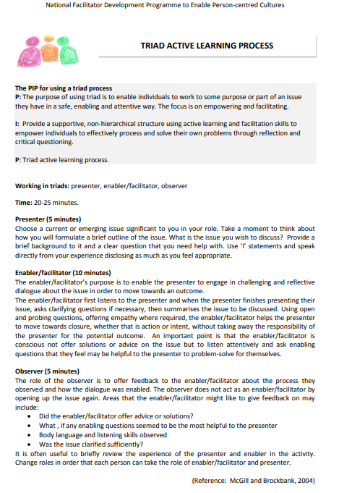

Appendix 2 ROSE; THORN, BUD model (Agarwal & Bain, 2019)
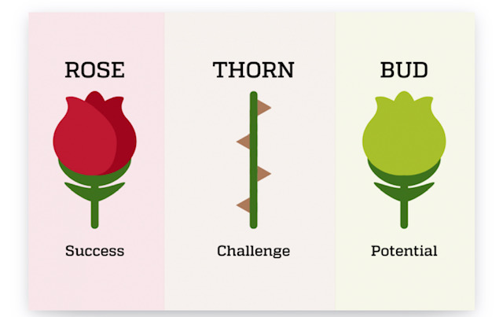

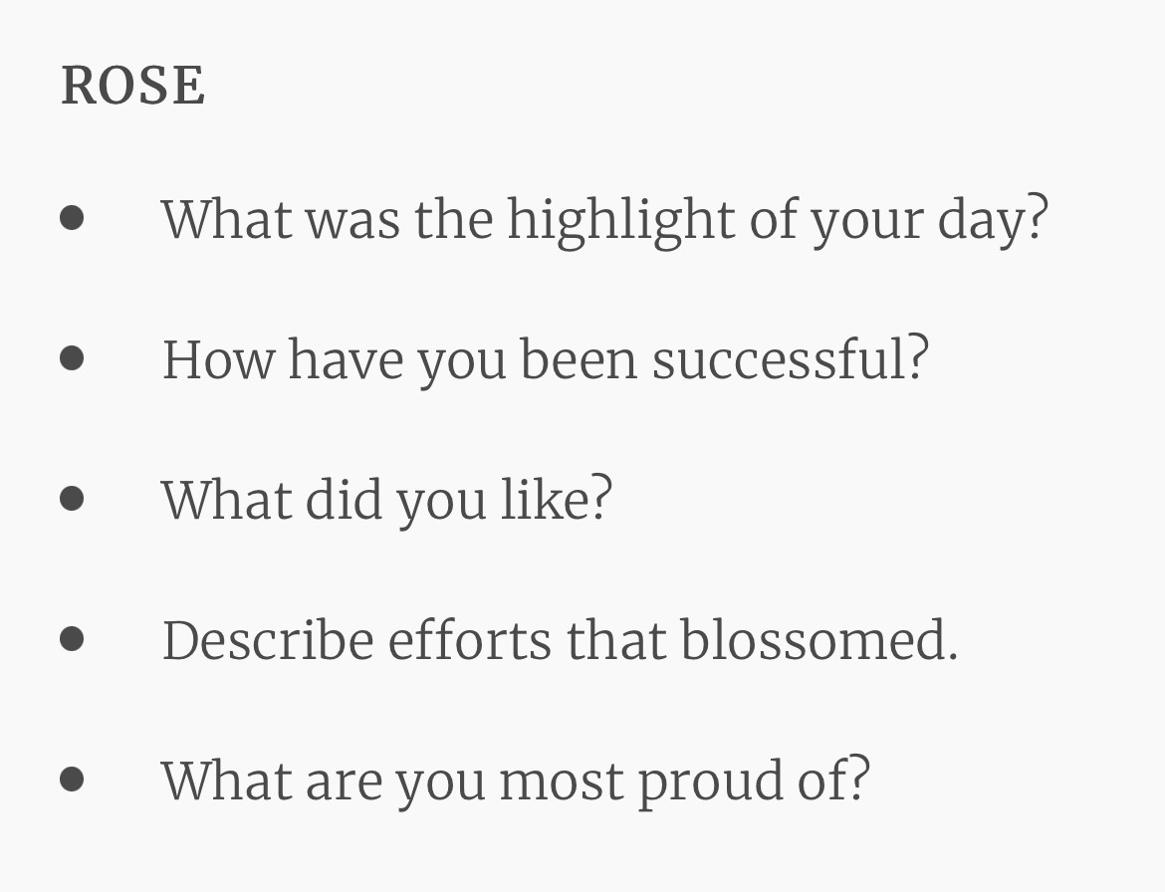

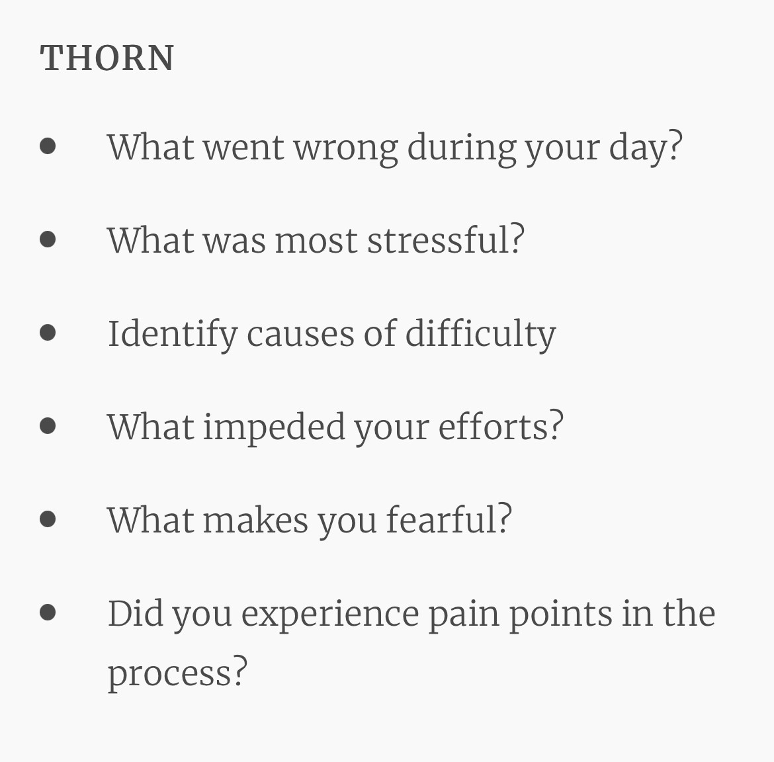
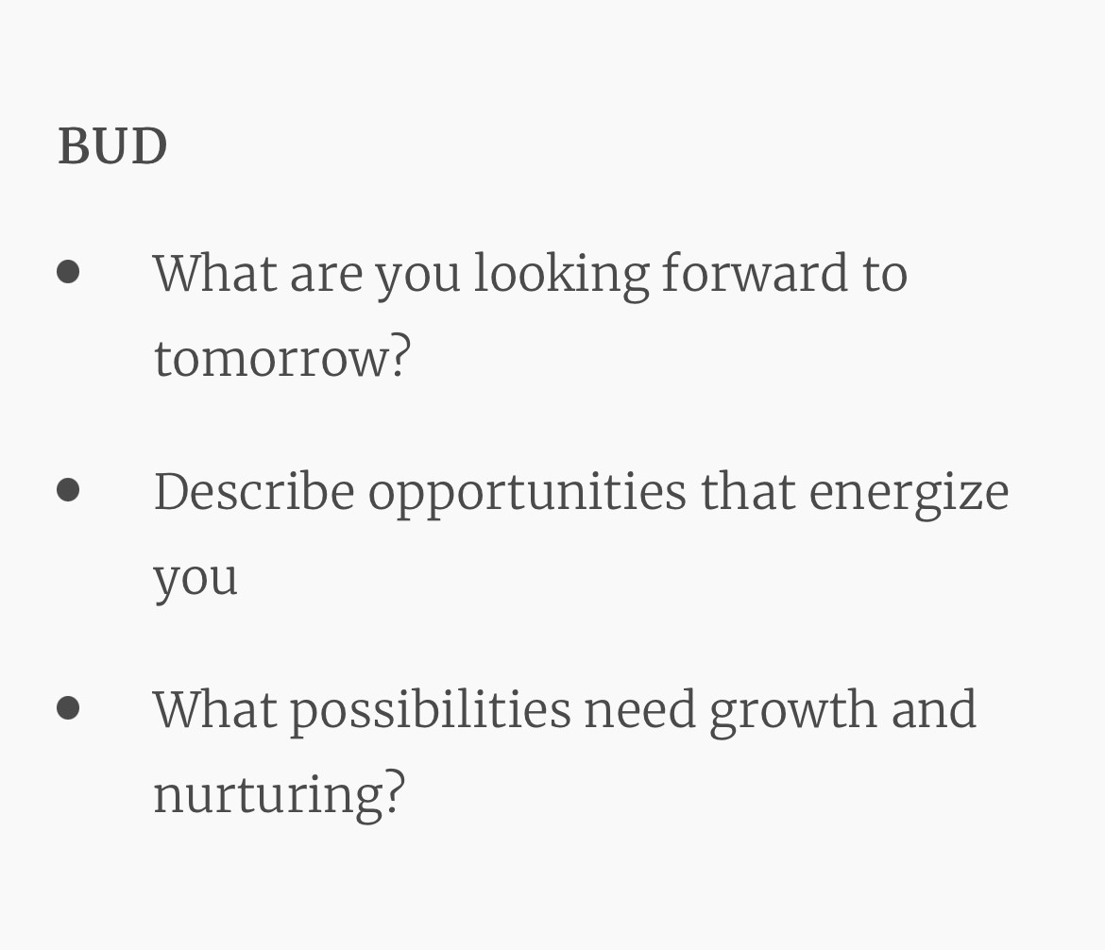

Appendix 3 - John’s Reflective Model (1995)

Reflective Phase | Critical questions | Response
Aesthetic | What was I trying to do? Why did I think or act in that way? What were the consequences? How did I feel in that situation? How was the other person feeling? How do you know how the other person was feeling?
Personal | How did I feel and act in the situation? What internal or external factors influenced my decisions?
Ethics | How did my actions match my beliefs?
Empirics | What knowledge informed me?
Reflexivity | How does this connect with other experiences?
Actions | What does this mean for me and my practice moving forward?

Appendix 4 - Gibb’s Reflective Model

Reflective Phase | Critical Questions | Response
Description | What happened?
Feelings | What were you thinking or feeling?
Evaluation | What was good and bad about the experience?
Analysis | What sense can you make of the situation?
Conclusion | What else could you have done?
Action Plan | If it arose again, what would you do?

Appendix 5 - Facilitated Reflection

Group Reflection
Mutual support in any team is key. Everyone in the team needs to look after everyone else and watch out for signs of stress and overload in colleagues. Coming together at beginning of shift and towards end of shift provides opportunities to reflect together and offer mutual support. Teams that work well together and communicate effectively perform better and provide safer care.
The shift leader is the most logical person to lead this but please look after the leader too, everyone can take a turn in facilitating this.
Here are some prompts that you can use to start to shape an end of shift group reflection:
- Was communication clear?
- Were roles and responsibilities understood?
- Was situational awareness maintained?
- Was workload distribution equitable?
- Was task assistance requested or offered?
- Were errors made or avoided?
- Were resources available?
- What went well?
- What should improve?
- Are you feeling safe to go home?
You can also consider for your area setting up a group checklist – for example for nightshift you could use the I’s Safe (I’M SAFE Tool (patientsafetyinstitute.ca)) tool at points during the shift to check on each other’s wellbeing:
I - illness
M - medications
S - stress
A – alert to drive
F - fatigue
E - eaten
Staff may write on coloured post-it notes for end of shift reflection and you could keep them in a journal for your team leader or facilitator of reflective spaces to refer to. This will help you all see if you have effectively addressed issues within the team or if the same issues keep arising and need some more / different effort.

Appendix 6 – Values Based Reflective Practice (VBRP)
What is VBRP® and how does it work?
VBRP® is a registered NES model which is all about conversation; it helps staff take time out to look at what’s going on for them, and aims to support staff so that they are more able to provide the care they came into the service to offer.
VBRP® takes place within a group held by a trained facilitator, and the reflective tools used in VBRP® are designed to keep the process safe and confidential. During a session which lasts around 30 minutes, staff are encouraged to think in different ways about their working life, maybe something which has “tugged” at them, or impacted upon them, for some reason.
Very often, people don’t ask for help until there is a sense of crisis and a feeling that “I am not coping”. VBRP® is a regular form of support which can be embedded in our working lives, reducing the build-up of stress.
It uses two simple tools: three levels of seeing and the NAVVY tool. These are used to enable people to make the connections between their personal motivations, actual practice and potential for our future practice. You can use these simple tools in everyday practice as a safe and protected way for you and colleagues to reflect and be reminded to attend to our wellbeing more intentionally at work.
The first tool:
Three Levels of Seeing
- 1. I see / notice
observing without interpretation
- 2. I wonder / I am curious
questioning, turning things over
- 3. I perceive / realise
making connections

The second tool helps us to ask 5 questions of a situation:
NAVVY Tool
- N whose needs are being met /not met?
- A what does it say about our abilities or capabilities?
- V whose voice is being heard /not heard?
- V who / what is being valued /undervalued / over- valued?
- Y what does this say about you / me / us?

This is done within the context of looking at our:
M Motivation
Why we do what we do – our best intentions
What brought you into the profession?
A Actual Practice
What we find in our everyday work life – our day to day reality
How are the values expressed in your motivation play out in your most recent day at work?
P Potential Practice
How we would like to express our original values in our workplace.
What could it be like? How could you begin to express your initial vocational values when you return to work? What would you need?
VBRP helps us to reconnect WHY we do what we do – our motivation
With the WHAT of our everyday work lives – the nitty gritty of the working week
Leading to HOW we would like to express our original values within our workplace.
What are the benefits of using VBRP®?
Taking part in a VBRP® session enables staff to get behind the assumptions which we might make in the hurry of life in a busy hospital and to really hear each other
VBRP® doesn’t force a solution, but gives staff space to look at other possibilities and it does this in a safe and supportive way which leads to an increased level of trust within teams
Here are a couple of quotes from staff members who are part of groups:
“This is a brilliant mechanism to support individuals and teams in busy demanding environments. It offers teams a short time out to listen to one another, give supportive and encouraging feedback – to give staff ‘a voice’.”

And simply
“You give us the luxury of being heard.”
How can staff find out more and explore VBRP® further?
If this sounds as though it could be a useful support to you and your team there a number of next steps.
You can use these simple tools in everyday practice as a safe and protected way for staff to reflect and be reminded to attend to our wellbeing more intentionally at work.
You can book a facilitated VBRP® session by contacting me to arrange a Taster Session susan.rayner1@nhs.scot - Please get in touch for further details.
Training to become an accredited facilitator is available through NHS Grampian and bookable through Turas.

Appendix 7- MAP Planner
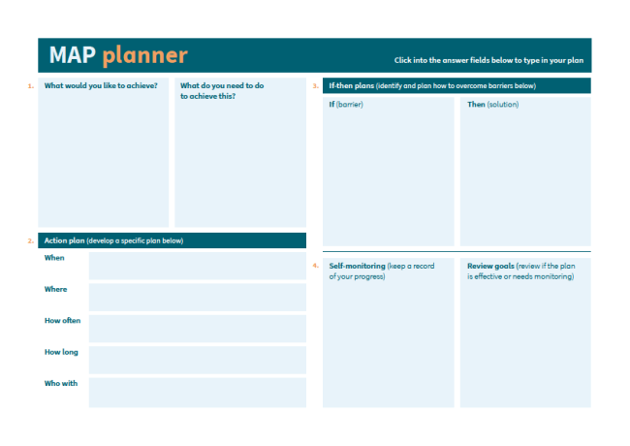

Appendix 8 - Spaces for Listening

Spaces for listening is another way of supporting teams to consider and reflect how they are feeling.
More information can be found here: spaces-for-listening-outline.pdf (nhsgrampian.org). If you think this would be helpful contact
Fiona Soutar – fiona.soutar@nhs.scot
Jason Nicol – jason.nicol@nhs.scot
Gerry Lawrie – geraldine.lawrie@nhs.scot

Appendix 9 - Care Spaces

If you feel you and your team would benefit from some external facilitation support to reflect then this can be facilitated by a member of the WeCare team - Care Spaces – What is a Care Space?
• A confidential, structured & facilitated space
• Asking questions that provide a supportive opportunity to:
• Connect with colleagues
• Listen and reflect
• Think about self-care
• Maximum group size of 8
• Talk in pairs and as a group
• 20 minutes
If you think your team would benefit from some time together to reflect using the Care Space approach then contact gram.support.acute@nhs.scot.

Appendix 10– Other sources of support for wellbeing

There are a number of internal sources of support – see the WeCare intranet site for most up to date information: NHSG WeCare Email gram.wecare@nhs.scot

https://www.nhsgrampian.org/your-health/wecare/
www.facebook.com/GrampianWeCare
www.twitter.com/GrampianWeCare
www.instagram.com/GrampianWeCare

Go Health Services Wellbeing Hub: Staff can complete an online referral via the link or by phone at 01224 5(55749). http://nhsgintranet.grampian.scot.nhs.uk/depts/Occupational%20Health%20Service/Pages/Counselling.asp x

Psychological Resilience Hub: Accessed via online self-referral form. https://www.nhsgrampian.org/covid-19/information-for-nhs-grampian-staff/subpages/mental-health-andpsychological-wellbeing-support-for-staff/

Chaplaincy Service: Chaplains who can assist you in reflecting on the circumstances you have found yourself in and help you with coping strategies. Phone 01224 553316 or for out of hours call the switchboard to page the on-call Chaplain on 880349.

Support for teams in Acute: Email RACH: gram.paediatric-psychology@nhs.scot ARI/DGH gram.support.acute@nhs.scot

TRiM Support for traumatic events: Email: gram.trim@nhs.scot

External sources of support:

- Our Frontline: https://www.mentalhealthatwork.org.uk/ourfrontline/
- Frontline 19: https://www.frontline19.com/
- NHS Practitioner Health: https://www.practitionerhealth.nhs.uk/accessing-the-service-in-scotland
- Carers UK Information and Support: Call 0808 808 7777 or contact by email: advice@carersuk.org
- RCN Counselling service | Royal College of Nursing (rcn.org.uk)
- Living Life: Phone line open Mon-Fri 1pm-9pm. Tel 0800 328 9655.
- Time for You – SAMH Mental Health and Wellbeing Support | SAMH

